What We Will Need To Place Your Order

- Floor Plan - this can be a copy of the blue print, or on any paper that shows the dimensions of the kitchen area with windows and doors noted (graph paper enclosed). Regarding the windows and doors, please indicate center of item and then to the edges of the trim (if any) or edges of the item. See page 2.
- Refrigerator Width.
- Stove Width.
- Vanities: if you are needing a vanity or vanities let us know the size(s) you want and what side the drawers need to be on, (for vanities above 30”). Vanities starting at 42” can have a double column of drawers.
- Due date.
- Address of the home: (that the cabinets are going to.)
- Color for the cabinets. See samples included with kit.
- Any extra cabinets, (for the laundry room, toilet toppers, linen closets, etc.)
- Any matching furniture (entertainment center, sofa table, coffee table, etc.)
- Moulding Information, if moulding is ordered. (Type, Total LF Needed) (Contact us for pricing).
- Send us pages 2 – 6 when complete. See page 6 on how to contact us.

Any Questions or concerns please feel free to contact us at any time.

Accurate measurements are essential for a successful design! By following these simple step-by-step instructions, you can provide the information needed to ensure proper fit of cabinetry and appliances. So, let’s get started! You may use plain paper or if you prefer, graph paper is provided on page 4 of these instructions.

Begin by measuring your existing kitchen/bath floor plan. For best results, it is recommended to measure all walls at a point about 36 inches above the floor. You’ll want the tape measure to be taut when measuring, so an extra set of hands will be helpful. Begin in one corner of the room and measure to adjacent wall. Record this measurement (in inches), and proceed to next wall. Repeat until all walls are measured. Now, make a rough sketch of floor plan and transfer measurements to outside perimeter of drawing as shown below.

MEASURE DOOR & WINDOW OPENINGS
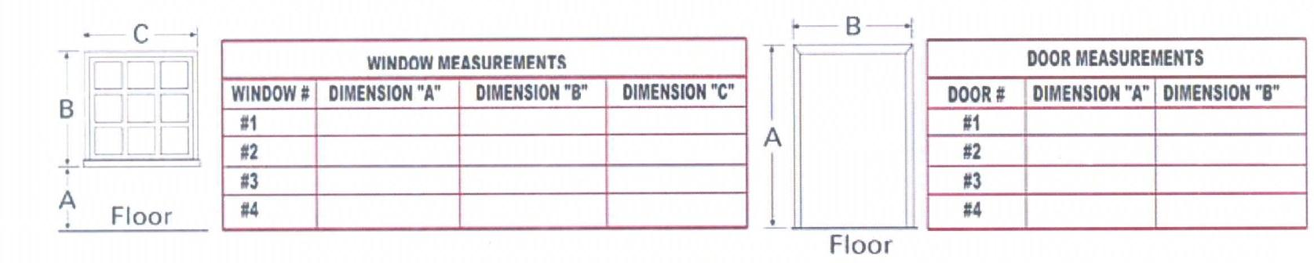
Measure each door and window in the kitchen and record on charts provided. Always measure from outside edge of trim to outside edge of trim. All measurements are to be stated in inches.

DOOR MEASUREMENTS

WINDOW MEASUREMENTS

Please check any of the following that you would like to see incorporated into your design:

□ WALL CROWN MOULDING* □ QUARTER ROUND MOULDING* □ CASE MOULDING* □ BASE MOULDING* □ MICROWAVE CABINET □ 24" DEEP OVER REFRIGERATOR CABINET □ SIT DOWN DESK WORK AREA □ KITCHEN ISLAND □ LAZY SUSAN CORNER CABINET □ CORNER WALL LAZY SUSAN □ ROLL-OUT TRAYS □ FULL EXTENSION DRAWER GLIDES
□ ADDITIONAL SHELVES □ OTHER ___________________________
*PLEASE SPECIFY UNPAINTED POPLAR OR FINISHED RED OAK

CONGRATULATIONS! You have completed the measuring requirements and are on your way to that new kitchen or bath. Send us the completed pages along with the provided cover sheet, via fax, email or by post. We will notify you by email when we receive your design request, and our Design Team will begin creating your new kitchen and bath!

Thank you for choosing IPI Habitat Cabinetry Program

NOTES:_________________________________________________________________________________________________________________________________________________________________________________________________________________________________________________________________________________________________________________________________________________________________________________________________________________________________________________________________________________________________________________________________________________________________________________________________________________________________________________________________________________________________________________________________________________________________________________________________________________________________________________________________________________________________________________________________________________________________________________________________________________________________________________________________________________________________________________________________________________________________________________________________________________________________________________________________________________________________________________________________________________________________________________________________________________________________________________________________________________________________________________________________________________________________________________________________________________________________________________________________________________________________________________________________________
Fax to: 319.372.2856

Email to: fmsales@iastind.state.ia.us

Total number of pages including cover page: ______

Check boxes for information included in this package:

FLOOR PLAN DRAWING
INFOR ON VANITIES
INFORMATION ON COLOR, DUE DATE, ADDRESS OF HOME, EXTRA CABINETS AND/ OR FURNITURE. (NOTES)
PAGES 3 – 5 OF MEASURING GUIDE

YOUR CONTACT INFORMATION:

NAME: ____________________________________________________
STREET ADDRESS: _________________________________________
CITY: _____________________STATE: _____ZIP CODE: ___________
BUSINESS PHONE: _______________CELL PHONE: ______________
BEST NUMBER AND TIME TO CALL: ___________________________
EMAIL: ______________________________FAX: _________________

